# Eureka 主机名修改 及 显示服务对应的IP名称

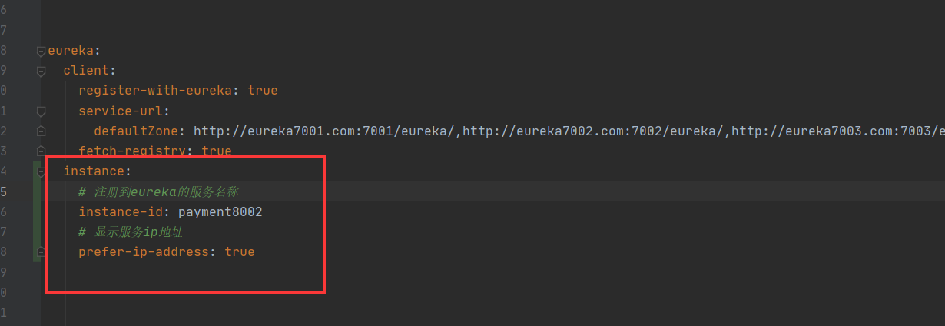

判断服务启动状态

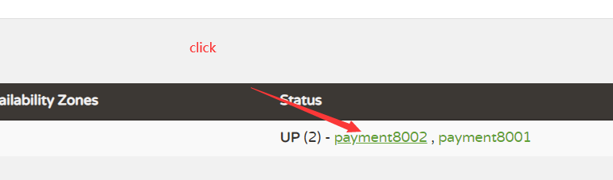

/actuator/health

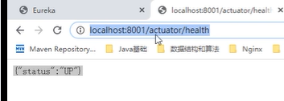

# Eureka 服务发现 discovery

相当于说明文档之类的，调用接口获取对应服务的相关内容

拥有哪些服务

某个服务集群子集 ip、服务名称、端口

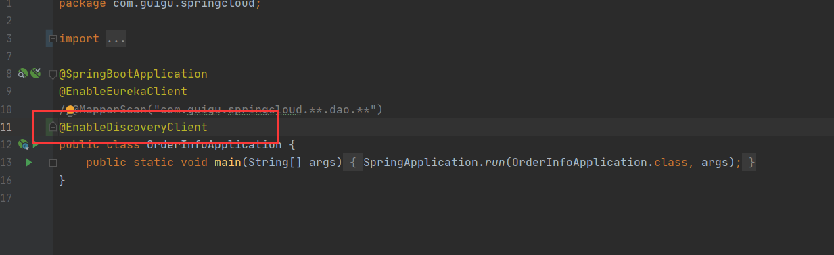

@Resource  
private DiscoveryClient discoveryClient;

@GetMapping(value = "/payment/discovery")  
public Object discovery() {  
 List<String> services = discoveryClient.getServices();  
 for (String serve : services) {  
 *log*.info("****element:" + serve);  
 }  
  
 List<ServiceInstance> instances = discoveryClient.getInstances("CLOUD-ORDER-PAYMENT");  
 for (ServiceInstance instance : instances) {  
 *log*.info(instance.getServiceId() + "\t" + instance.getHost() + "\t" + instance.getUri());  
 }  
 return this.discoveryClient;  
}

# Eureka怎么禁止自我保护

Eureka 服务端

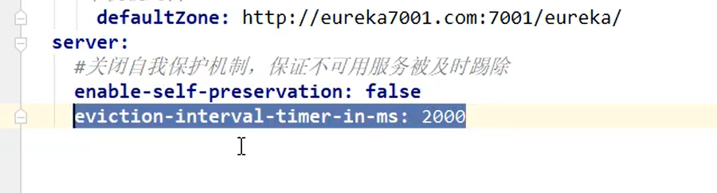

Eureka 客户端

